**Lab13**

**Name of Your Lab**

***Objective***

In this section include what topics will they learn

***Background***

In this section give a short description of topics and tell the story that goes with your lab.

***Specification***

In this section explain what the problem of the lab is and what the end goal is. Include detailed step by step instructions on how to complete your Resource class. Use the following template for your step by step instructions. Fill in the blanks, delete unnecessary text, and add additional information as needed.

You are creating a resource class named _______Lawn Mower___________. It is a subclass of _______Athlete___________. It implements the __________Grass and runnable______ interface.

The class defines __2__ constructors.

The first constructor is a default constructor.

This constructor invokes the superclass 4-arg constructor, using starting values of: __2__, __2___, ___________Display.EAST_____________, ___0__.

The second constructor is a 1-arg constructor.

This constructor invokes the superclass 4-arg constructor, using the 1 argument as the number of beepers and __int x__, __int y___, and ______int dir__________________ as the other starting values.

The class defines __10___ methods.

The name of the first method is ________goToHouse_______________.

The precondition for the method is ____________________Must be at the curb facing North________________________.

The post condition for the method is _________Must be facing west toward the entrance of the lawn _________________________________.

Additional information you should know about the method is _________it doesn’t matter how far the lawn is from the curb_______________.

Also show before and after pictures of at least 1 display.

start: 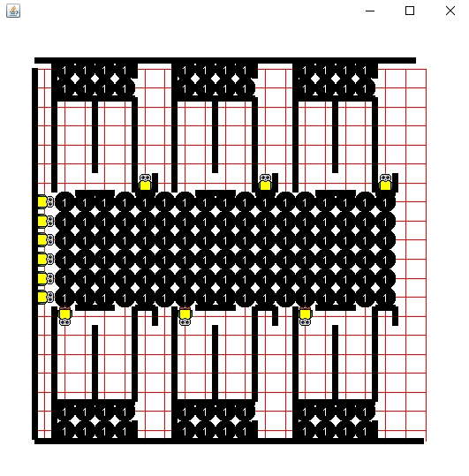

End: 